**HEXADECIMAL TO DECIMAL CONVERSION**

**AIM:**

To convert a hexadecimal number into its decimal equivalent using the 8085 microprocessor.

**ALGORITHM:**

1. **Load the hexadecimal number** into a register (e.g., register B).
2. **Clear accumulator and initialize result register** (e.g., register D) to store the decimal value.
3. **Initialize a counter** to track position (e.g., for multiplying by powers of 16).
4. **Extract each nibble** (4 bits) from the hexadecimal number using masking and shifting.
5. **Convert each nibble to decimal** by multiplying with appropriate power of 16.
6. **Add the result to the accumulator or result register**
7. **Store the final decimal value** in memory.
8. **Terminate the program** using HLT.

**PROGRAM :**

MVI B, 2FH

MOV A, B

ANI 0F0H

RRC

RRC

RRC

RRC

MOV C, A

MVI A, 10H

CALL MULTIPLY

MOV D, A

MOV A, B

ANI 0FH

ADD D

STA 2200H

HLT ; End program

; --- MULTIPLY SUBROUTINE ---

MULTIPLY: MVI E, 00H ; A = A × C

; Clear E (accumulator for result)

LOOP1: ADD E ; Add A to E

DCR C ; Decrement counter

JNZ LOOP1 ; Repeat until C = 0

MOV A, E ; Move result to A

OUTPUT :

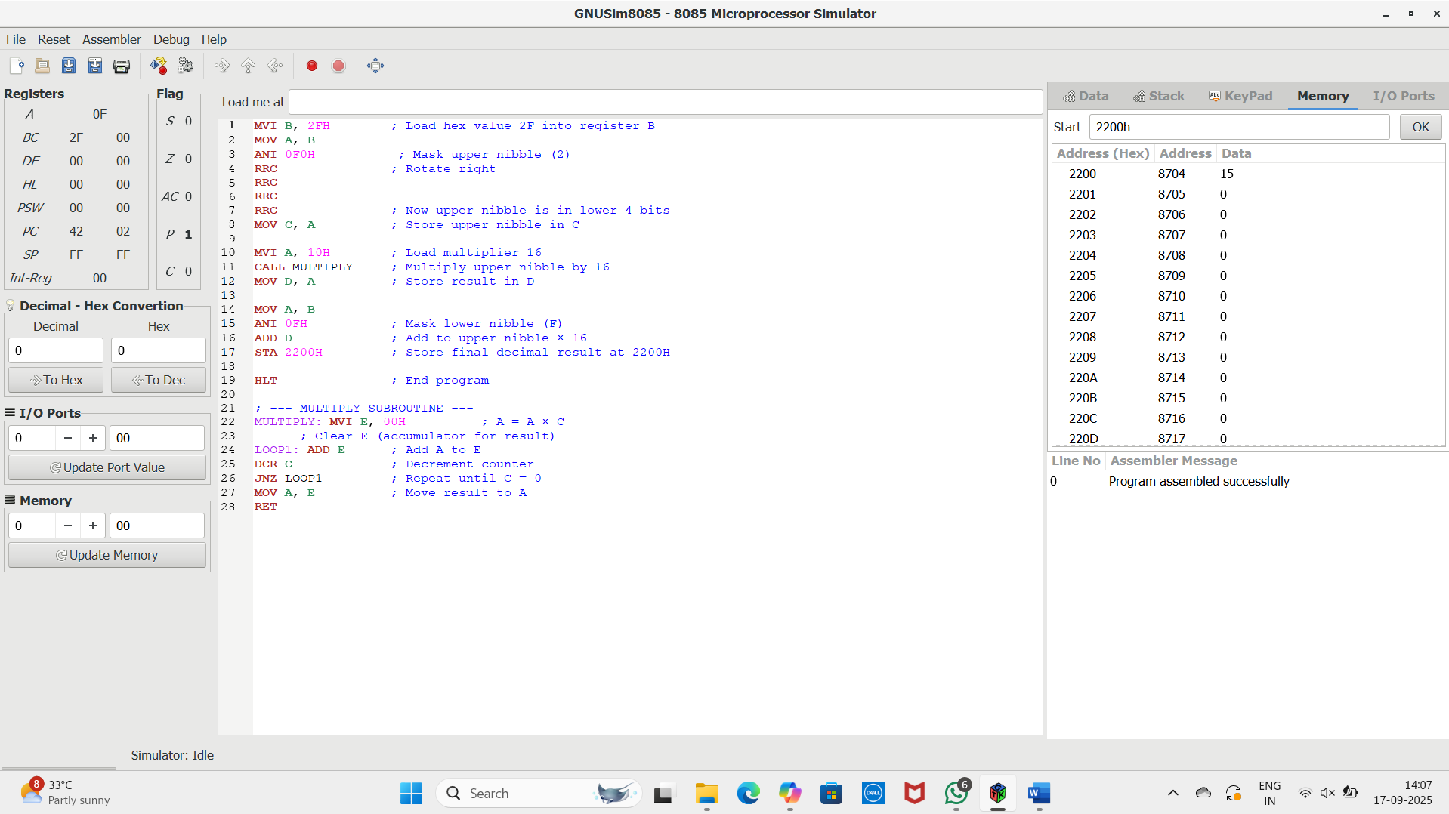

**RESULT:** Thus the program was executed successfully using 8085 processor simulator